**Curriculum Plan**

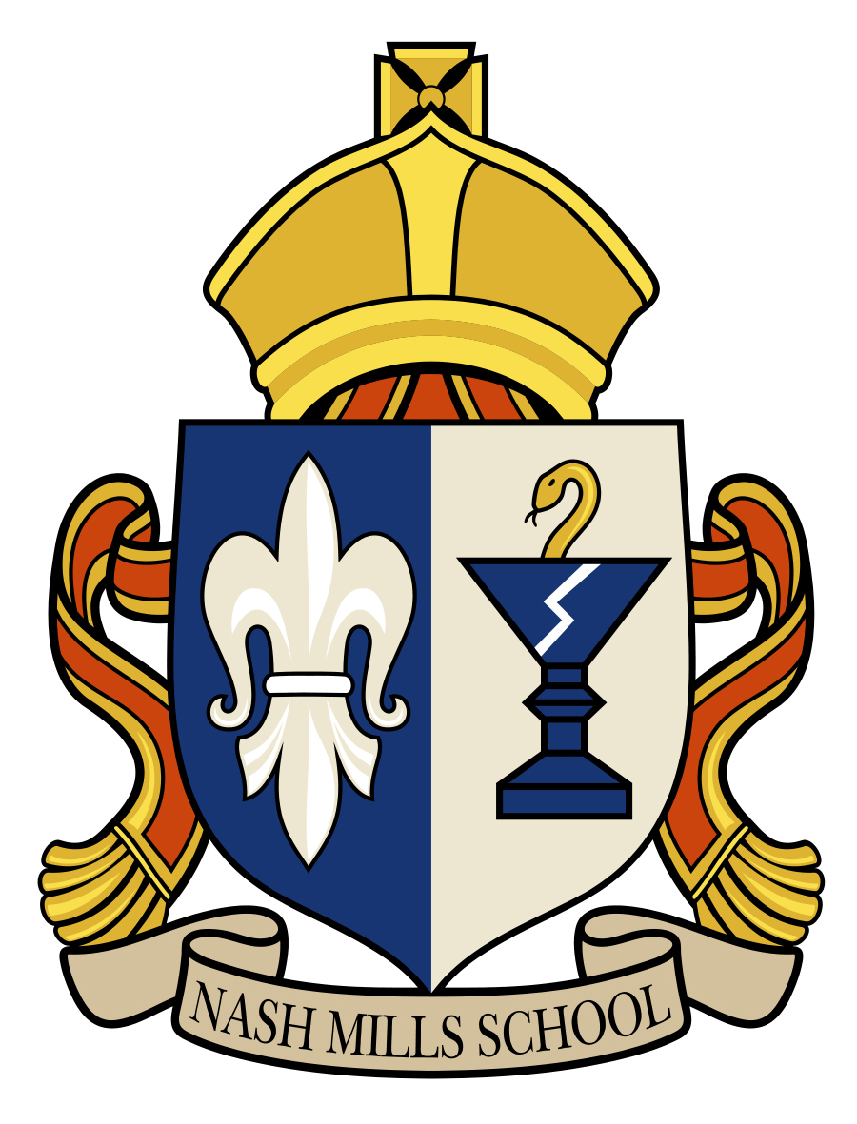

**Year Group: 2 Staff: Sophie Brewer**

|  |  |  |
| --- | --- | --- |
|  | **Summer Term** | |
| English | **Traditional tales- Recurring language-**  **Rapunzel**  **Jack and The Bean Stalk** | **Recount-**  **Vlad the Flea**  **Explanations-**  **Monsters**  **Poetry-**  **Quangle Wangle’s Hat** |
| Humanities – History and Geography | **Mapping** |  |
| **Great Fire of London** | **Local Study**  **London** |
| Science | **Enquiry** |  |
| **Plants** | |
| RE | **UC**  **God**  **What do Christians believe that God is like?** | **D**  **Does completing Hajj make a person a better Muslim?** |
| Art & DT | **Sculpture- monster eyes -clay** | **Food** |
| Music | **Friendship Song** | **Reflect, Rewind, Replay** |
| PE |  |  |
| Computing | **Internet Safety** |  |
| **Using and Applying** | **Computer Art** |
| PSHE | **Relationships** | **Changing Me** |